|  |  |
| --- | --- |
| C:\Users\Touseef\Desktop\download (1).png | **AIR UNIVERSITY** |
| **DEPARTMENT OF MECHATRONICS ENGINEERING** |
| **LAB NO 2** |

**Lab Title** universal joint

**Student Name:** Muhammad Abdullah Khan **Reg. No:** 221748

**LAB ASSESSMENT:**

|  |  |  |  |  |  |
| --- | --- | --- | --- | --- | --- |
| **Attributes** | **Excellent**  **(5)** | **Good**  **(4)** | **Average**  **(3)** | **Satisfactory**  **(2)** | **Unsatisfactory**  **(1)** |
| **Ability to Conduct Experiment** |  |  |  |  |  |
| **Ability to assimilate the results** |  |  |  |  |  |
| **Effective use of lab equipment and follows the lab safety rules** |  |  |  |  |  |

Total Marks: Obtained Marks:

**LAB REPORT ASSESSMENT:**

|  |  |  |  |  |  |
| --- | --- | --- | --- | --- | --- |
| **Attributes** | **Excellent**  **(5)** | **Good**  **(4)** | **Average**  **(3)** | **Satisfactory**  **(2)** | **Unsatisfactory**  **(1)** |
| **Data presentation** |  |  |  |  |  |
| **Experimental results** |  |  |  |  |  |
| **Conclusion** |  |  |  |  |  |

Total Marks: Obtained Marks:

Date: 04-Oct-2023 Signature:

UNIVERSAL JOINT

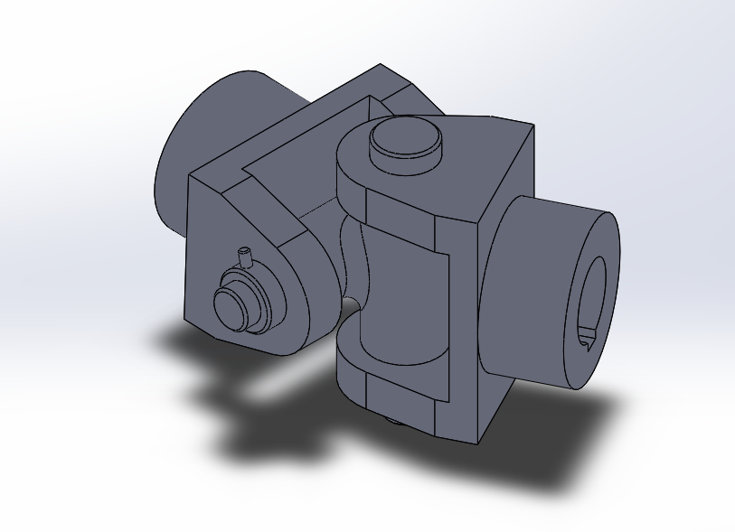

**PIN:**

***Pin is like a pin . it is simple sphere pipe shape.***

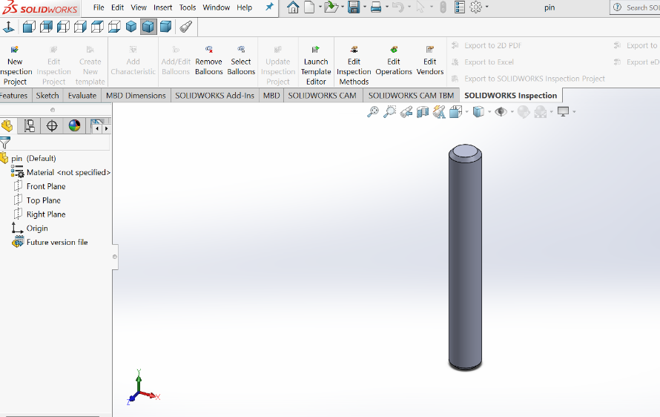

***1:sketch circle .***

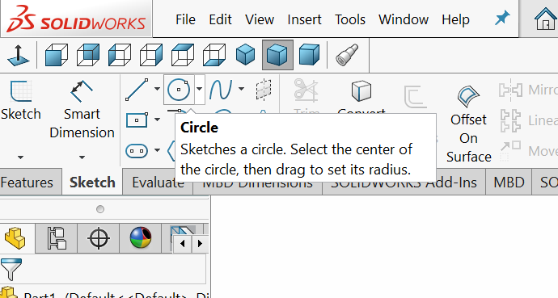

***2:make extruded boss base.***

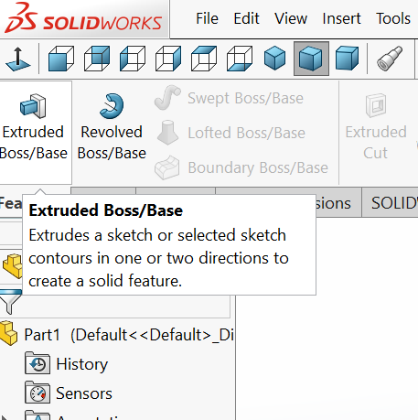

***3.give edge curve using fillet(chamfer).***

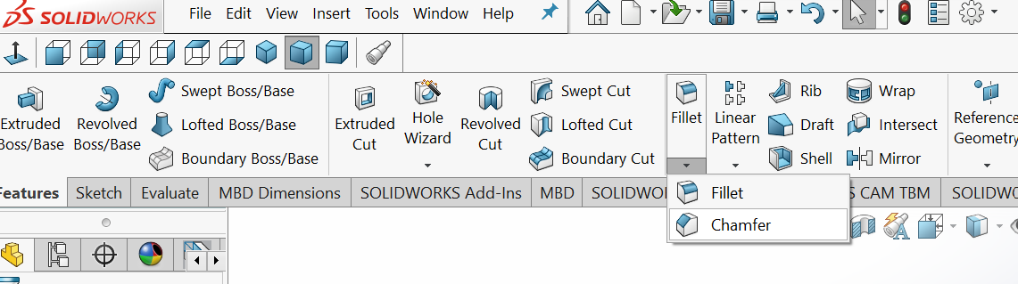

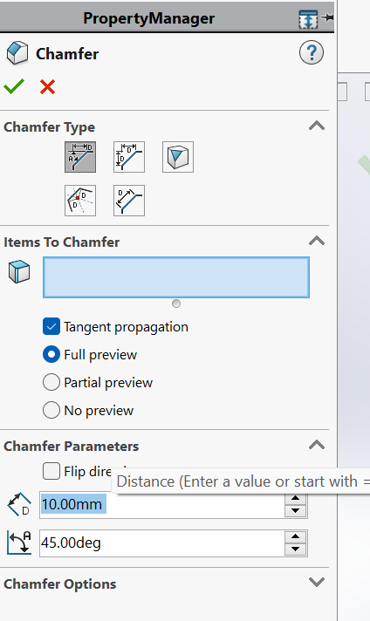

**6: select diameter.**

**BUSH:**

***To make universal joint first thing that we are going to make is bush. Bush is basically round shape with simple hole in centre and hole on 2 side opposite to each other.***

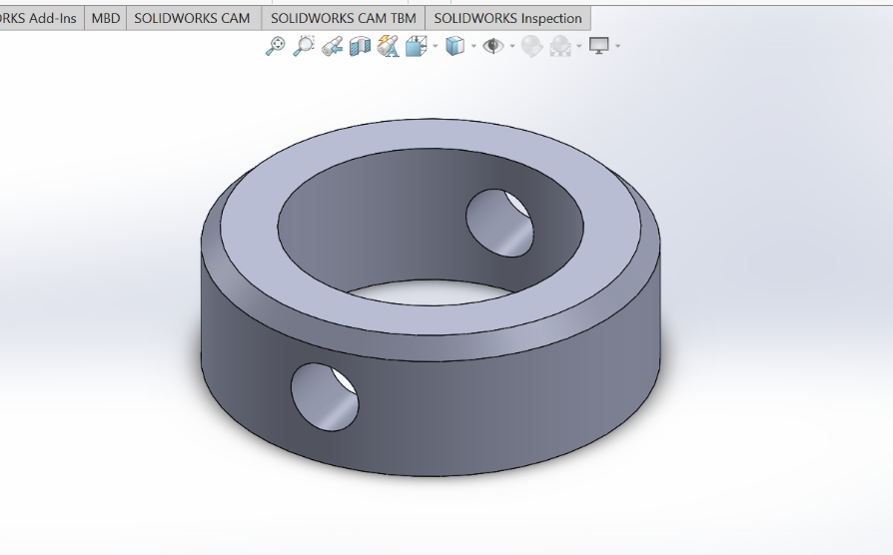

***1: Simply we sketched circle .***

***2: Made it in shape using extruded base.***

***3: Using fillet gave smooth curve on edges.***

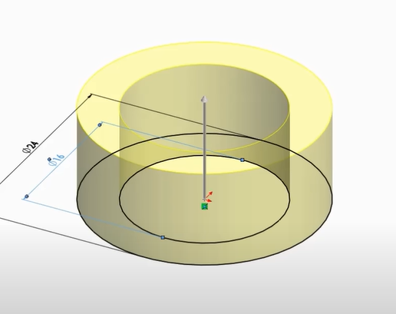

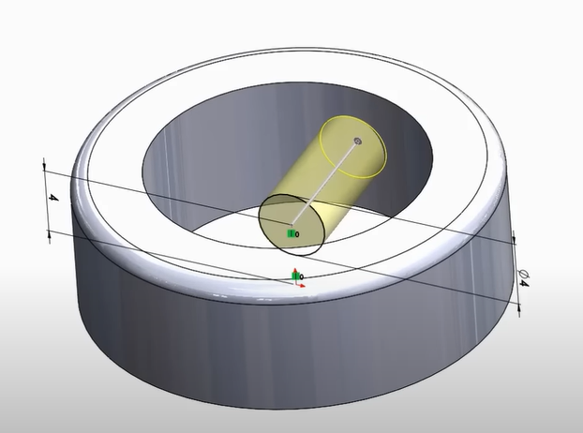

**BOLT:**

***Basically in bolt we have one side long extruded base and one short . Given hole on long side for attaching it.***

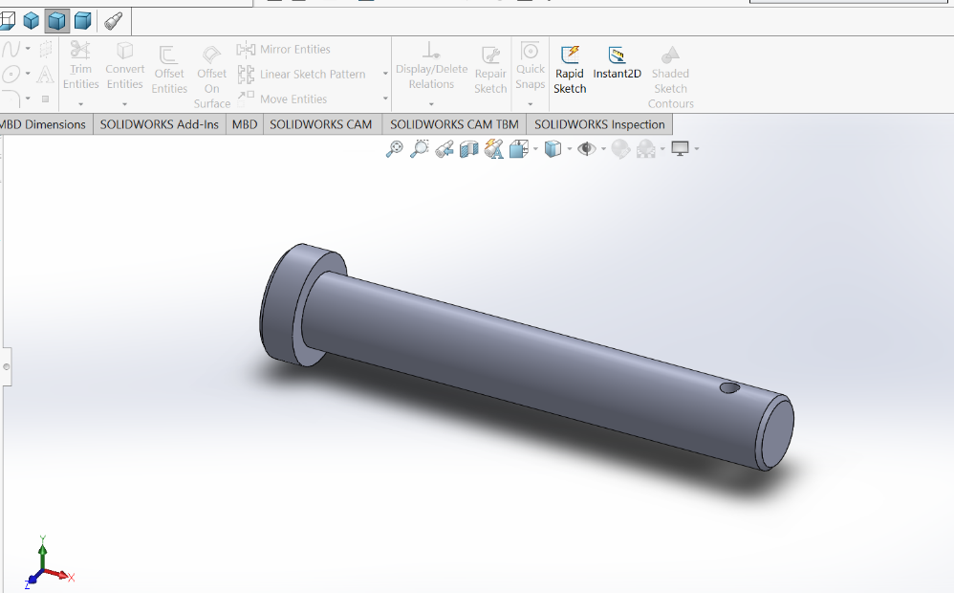

***1: Sketch a circle. Extruded boss base it.***

***2: make another cirle on made cirle . using extrude boss base make it little long.***

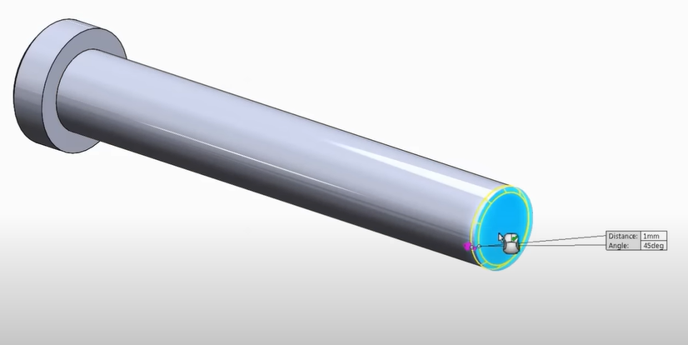

***3: using fillet give it curve on edges .***

***5: make distant small circle on long shape .***

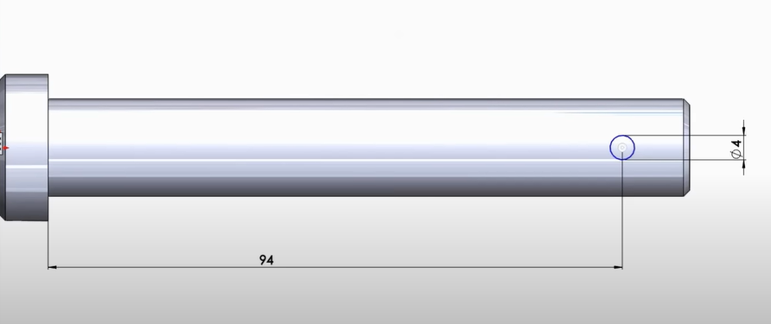

**DRIVING YOKE:**

***Driving yoke is base of universal joint all small body got joint with it. It has small sphere shape and given speciall shape using circle and attaching lines making tangent.***

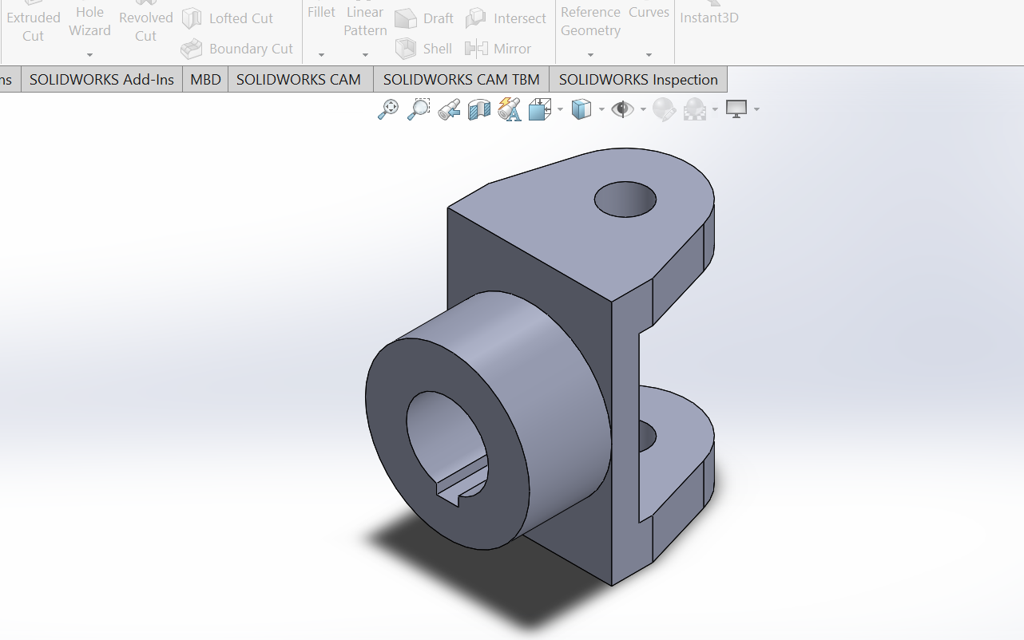

***1: make rectangle and extruded boss base it.***

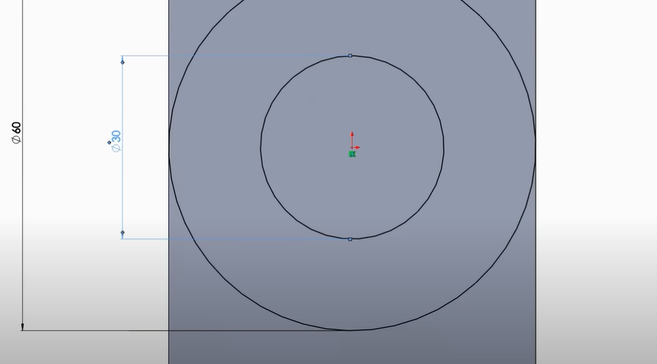

***2: make simple 2 circle using sketch. Then use extruded boos and base.***

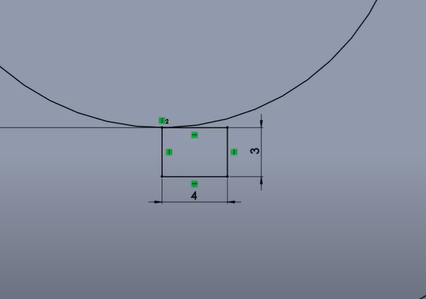

***3: make small rectangle under small circle. Then after making it trim all non needed lines to make into shape.***

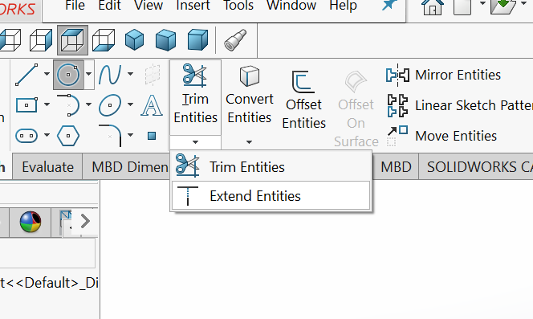

***4.make circle on head of outer sketch. Join cirle with line.***

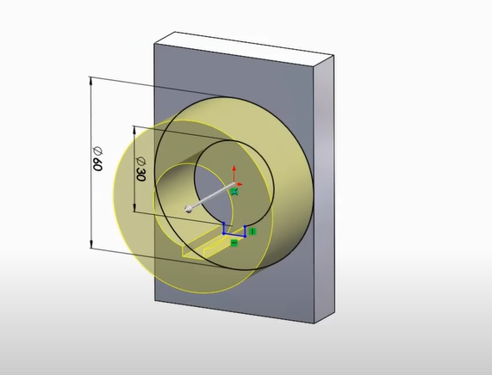

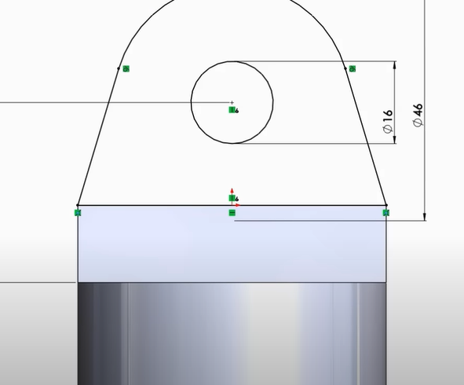

***5:then tangent it . mirror same drawing after extruded boss and base.***

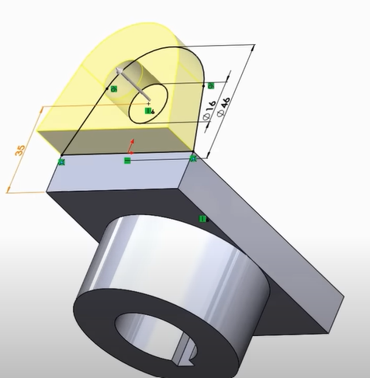

**BEARING CROSS:**

***In this shape . we made 2 circles on each other.***

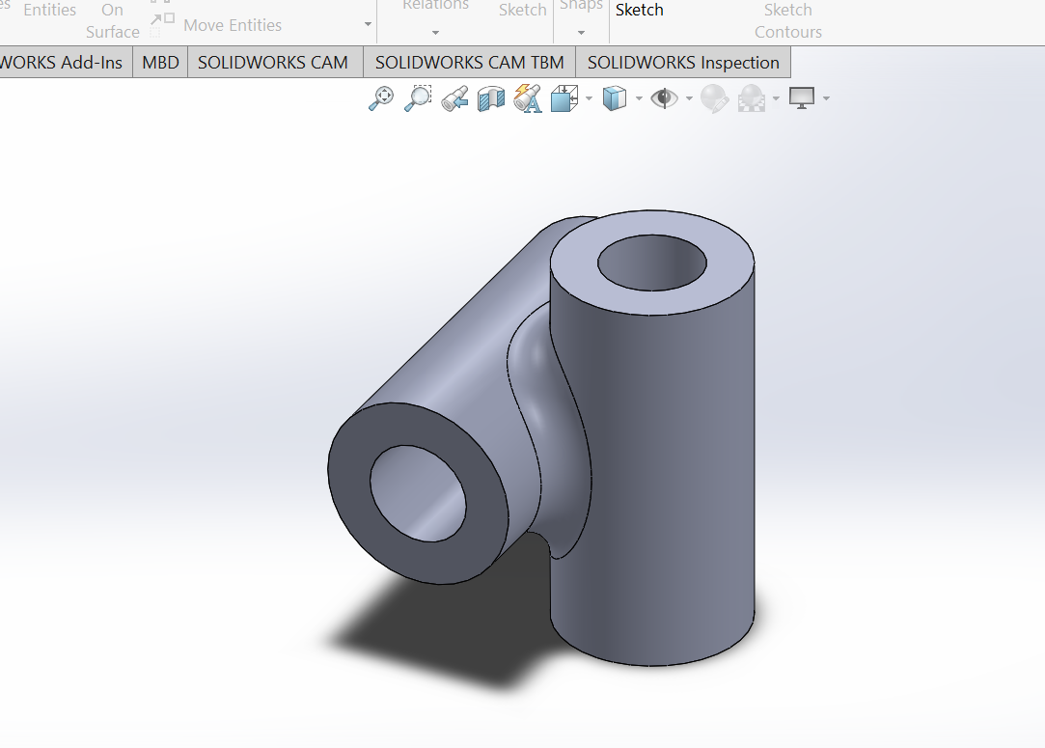

***1: draw 2 cicles. Extrude boss base it .***

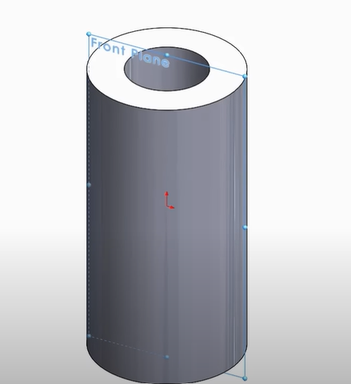

***2. near horizzontal made shape make 2 more circle on it.it will create joint inside circle.***

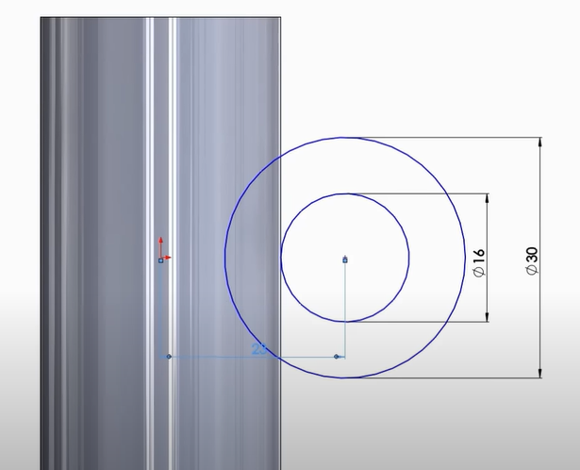

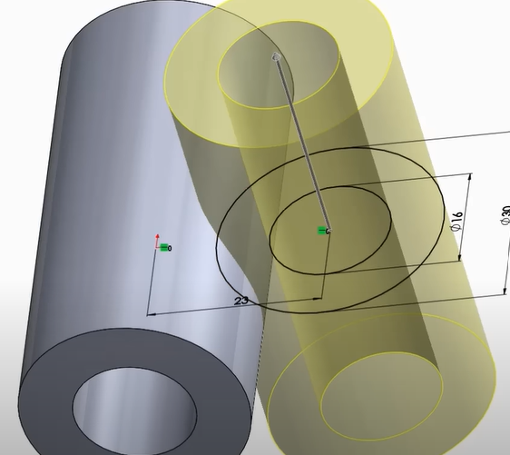

***3: Using filler give it proper curve.***

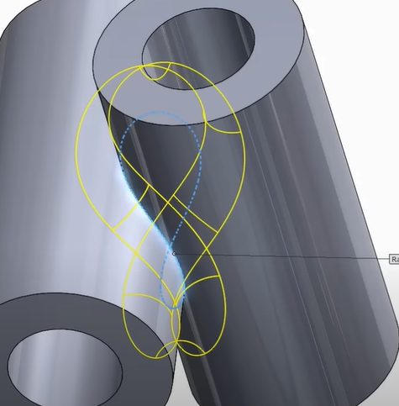

**ASSEMBLY:**

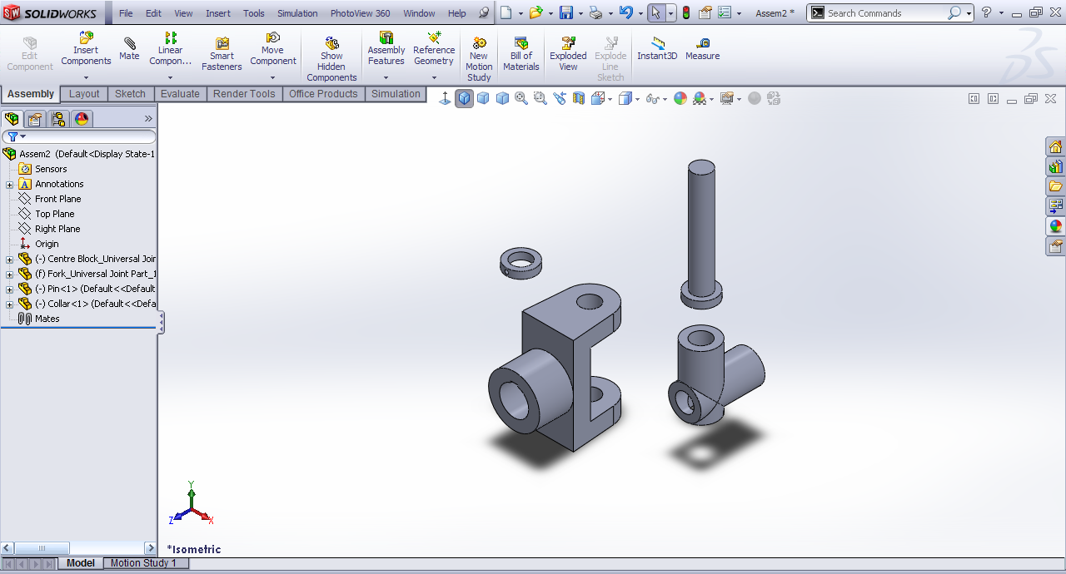

***Open assembly.***

***Bring all component.***

***In mate bring all into each other.***

***Copy needed part by clinking on it with ctrl key.***



***This completes our assembly as all parts are now fixed in there specific positions and now we can use motion study to give and record its motion***

***CONCLUSION:***

***To conclude, we learned many new features including Dynamic Mirror and width feature got our hands set on mate feature and mirror feature and trim property.***